Sample Pilot Checklist (Front) |  | Custom Pilot Checklist (Front)
Balloon Pre-Flight
1). PREFLIGHT  • Weather Briefing  • Flight Plan  / Airspace  • Documents  • Fuel Check  / Pressure  • Burner / Leak  Check  • Crew Brief  • Passenger Brief  • Layout & Assembly  • Pre-Flight  Inspection  • Fan Placement  • Instrument  / Radio Check  • Basket Check  • Go Hot  / Equilibrium  • Board Passengers | Equipment Checks  • Striker(s)  onboard  • Burner Test  • Basket /  Envelope  Connection  • Instruments  on / Working  • Basket  tied off  • Water on  board
Sample Pilot Checklist (BACK) |  | Custom Pilot Checklist (Back)
Launch / Landing
- Launch Checklist  • Final Crew Brief  • Fuel / Pressure  • Red Line Check  • Parachute  Check / Set  • Instrument Check  • Start Flight Tracker  • Passenger Brief  • Obstacle(s)  / Traffic Clear | 3) POST FLIGHT  • Fuel Off  • Radio Off  • Burner Off  • Balloon  Packed  • Basket  Secured  • Landowner  Gratitude  • Refuel  Tanks  • Log Flight  Fly Well  Have FUN  BE SAFE |  |  | Fly Well  Have FUN  BE SAFE
2) Landing Checklist
• Passenger Brief
• Crew Instruction
• Landowner
Permission
• Fuel Level Check
• Redline Check
• Obstacle(s) / Traffic
Clear
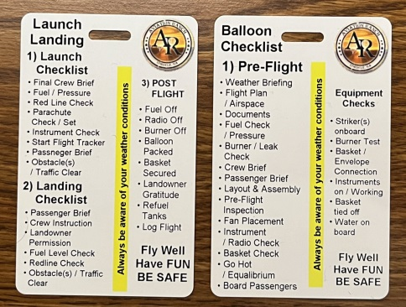 |  | Remember the more text you write the smaller the text becomes on the printed card. If you can keep the number of words similar or fewer the card will be much more readable.  Fill in this form. Save the file with your name and email back to us and we will create your custom Crew Checklist.  File name should be PC”yourname”  PC for Pilot Checklist and your name.  Email this form to jeff@balloons-andbeyond.com  Attach a photo of your balloon!

