Sample Crew Checklist (Front) |  | Custom Crew Checklist (Front)
Ground Team Checklist
1). Pre-Flight  Assemble Baskets  Escort Guest to  Briefing Area  Prepare Pi-Ball  2).Inflation  Off Load Basket, Envelope & Fan. Check fan for Gas. Open Envelope bag and attach to basket. Drag out envelope and unroll Crown Line. Tab Parachute. Use crown to stop balloon in the straight up position. Bring crown line to pilot. Move fan away from basket. Assist passengers getting in balloon. | Balloons Away  Load Fan, Cans, Ropes. Scour the area for Lost items. Secure all straps Gates and Doors. Radio Check your Pilot. DRIVE. Drivers do not watch balloon(s)
Sample Crew Checklist (BACK) |  | Custom Custom Checklist (Back)
Crew / Landing Site
Seek permission. Leave keys in truck. Park out of Pilots way. Gloves on and be prepared to assist. Never get in front of balloon! Radio on you | After Flight Toast  Grab cooler hand out glasses, Pour Orange Juice. Put OJ in cooler under ice Clean up area. Scout area for lost objects.  Help  Passengers  Exit Vehicle  Report Any issues you observed.
Balloon Down
Help passengers exit balloon safely. Grab crown line and pull balloon down. Get bag for balloon to top of balloon. Unhook balloon from basket. Turn off Fuel and bleed lines, Disconnect lines Stand up basket, break down. Put away Radio & Pilot Electronics, Drive truck to balloon and load envelope and basket.
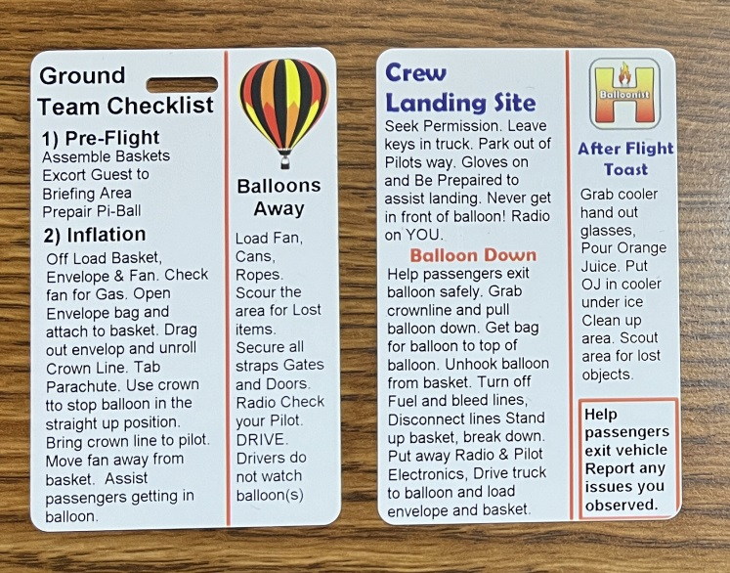 |  | Remember the more text you write the smaller the text becomes on the printed card. If you can keep the number of words similar or fewer the card will be much more readable.  Fill in this form. Save the file with your name and email back to us and we will create your custom Crew Checklist.  File name should be CC”yourname”  CC for Crew Checklist and your name.  Email this form to jeff@balloons-andbeyond.com  Attach a photo of your balloon!

